**This is a step-by-step guide of how to install an OS on the raspberry pi**

**Before we start you need to make sure you have these components**

**Requirements :**

1 – Micro Sd card at least 16 GB (storage)

2 – Raspberry pi and its accessories ( I will be using the Raspberry pi 400 with 8 gb of RAM

3 – HDMI to plug it to a monitor

4 – Computer / Laptop

5 – SD card reader

6 – Internet Connection

**Step-By-Step guide**

**(There are about 10 steps and you would need to follow to able to have a successfully installed OS )**

1st - insert your microSD card in the laptop

2nd – Install the Operating System you would like your raspberry pi (in my case I’m going to install Twister OS) which you can download it with this provided link <https://twisteros.com/download.html>

3rd – After successfully installing the Operating system than you would need to download the Raspberry pi imager (<https://www.raspberrypi.com/software/>) so you would be able to write it to your MicroSD card , and after that it installed it should look like this

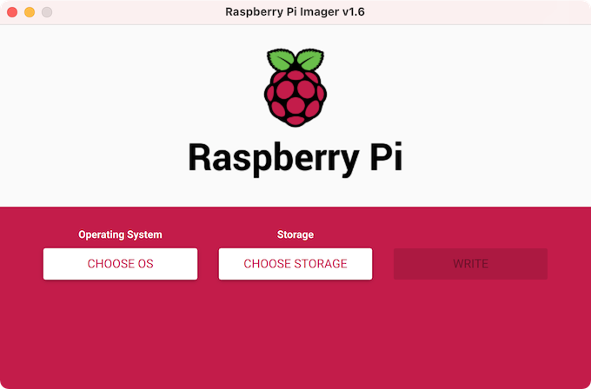

4th – Click on “Choose OS” and scroll all the way to the button and click “Use custom” (its all the way to the bottom )

5th – After you clicked “Use custom” it should look like this , select your installed operating system (As you can see I have a variety of operating systems but I’m going to use TwisterOS) after you have selected your operating system just click “Open”

After you have clicked Open it should look like this

6th – Click on “CHOOSE STORAGE” and select your MicroSD CARD

7th – After you managed to fill the OS and the Storage you can now press ” WRITE “ this will write the OS on the MicroSD Card.

This will take some time to finish so be patient

8th- After the writing is done you can now remove your MicroSD card from your laptop/computer and insert it into your raspberry pi make sure to connect its accessories such as (power supply) , (keyboard) , (mouse) , (MicroSD) , etc.

9th – If you have followed this step-by-step guide you should have no errors , and are able to see the Twister OS

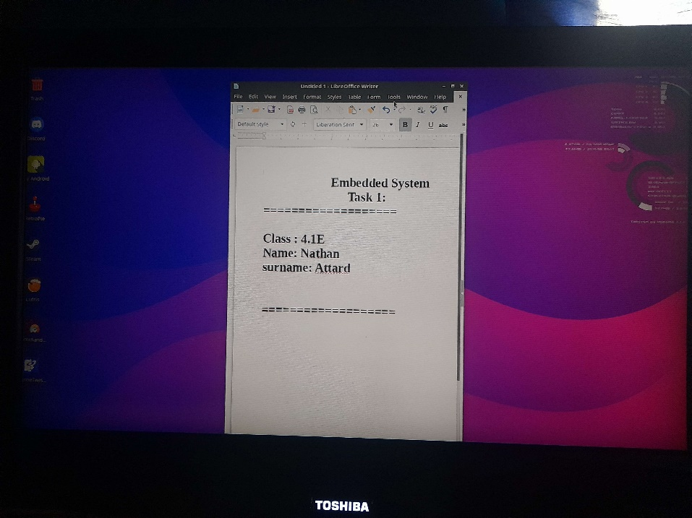

10th ) Have fun with your new installed Operating System : D

**FEATURES :**

The twister os includes several features such as :

1. Familiar user interface based on Raspberry pi OS desktop
2. Integrated App store for east installation of additional software
3. Customizable desktop themes and layouts
4. Support for Raspberry Pi hardware , including GPIO pins and camera
5. Built-in emulation for software classic gaming consoles
6. Ability to run android apps with Anbox
7. Included programming languages and tools for developers
8. A variety of multimedia apps for audio and video playback and streaming .
9. It provides an easy way to perform advances configuarion tasks , like overclocking , on your SBC
10. There are 11 different user interface themes , both modern and nostalgic. Whether you`re a Linux , Windows , or Mac user , you`ll feel right at home on Twister OS . Changing the entire look and feel of your OS is as easy as clicking a button in the included “ThemeTwister” app.

For more information please visit the official website of Twister and you are able to see more features and a more detailed description about Twister OS (<https://twisteros.com/about.html>)

**Conclusion :**

Twister OS has a user-friendly interface with a unique user experience with its customized UI and pre-installed software . It also offers additional features such as app store , system monitor and emulation software that make it a great option for Raspberry Pi users , looking for a more complete operating system experience